J**EWISH** R**ESIDENTS'** C**OUNCIL**

**To support the Jewish community spiritually, provide opportunities for religious and additional experiences, and encourage social interaction. To nurture respect, understanding and friendship among all residents and faith groups at Ann's Choice.**

**August 2025**

***Av/Elul* 5785**

**Friday, August 1: *Shabbat* Services in the Chapel or on Channel 980 – 4 p. m. Torah Portion: *Devarim* Barbara Steiner delivering the *D’var Torah***

***Shabbat Chazon***

**Sunday, August 3: TISH’A B’AV**

**Monday, August 4: Joe Shrager Memorial *Torah* Study, Liberty Commons Art Room 2 p.m.**

**Tuesday, August 5: Jewish Heritage-Judaism Today, Liberty Music Room, 1 p.m.**

**Friday, August 8: *Shabbat* Services in the Chapel or on Channel 980 – 4 p.m. Torah Portion: *Vaetchanan* Michael Eisman delivering the *D’var Torah***

***Shabbat Nachamu Tu B’Av***

**Monday, August 11: Joe Shrager Memorial *Torah* Study, Liberty Commons Art Room 2 p.m.**

**Friday, August 15: Shabbat Services in the Chapel or on Channel 980 – 4 p.m. Torah Portion:   
*Eikev* Michael Kaplan delivering the *D’var Torah***

**Monday, August 18: Joe Shrager Memorial *Torah* Study, Liberty Commons Art Room 2 p.m.**

**Friday, August 22: *Shabbat* Services in the Chapel or on Channel 980 – 4 p.m. Torah Portion:   
*Re’eh* Susan Sultanik delivering the *D’var Torah***

**Sunday, August 24: *Rosh Chodesh Elul***

**Monday, August 25: Joe Shrager Memorial *Torah* Study, Liberty Commons Art Room, 2 p.m.**

***Rosh Chodesh Elul***

**Wednesday. August 27: JRC Lecture Series 2 p.m. in the PAC with Leslie and Marvin Kreithen, Yiddish Theater EVERYONE WELCOME**

**Friday, August 29: NO SERVICES TorahPortion: *Shoftim***

**THANK YOU TO THE FOLLOWING FOR THEIR VERY GENEROUS DONATIONS TO THE JEWISH RESIDENTS' COUNCIL:**

**BY IN MEMORY OF**

Michael Eisman and Sherry Kohn Deborah Gene Eisman, beloved daughter

Marilyn and Donald Webster Benjamin Pomerantz, beloved uncle

Roslyn Katz Edward Katz, beloved husband

Gloria Salmansohn Edward Smiley, beloved brother

Adelheide Benjamin, dear friend

Lenore Epstein beloved husband, father and grandfather, Robert Epstein

Shirley Stein Phillip and Anna Baker

Manny Stein

Elana Stein

Laurie and Stephen Capin Ivan Kaminoff

Jeanne & Daniel Kushner

Ivan Kaminoff

Abe Goll

Phyllis Halpern Ivan Kaminoff

Abe Goll, beloved husband of Barbara Goll

Richard Alexander, beloved husband of Jan Alexander

Betty Chary Richard Alexander

Ethel & Bernard Randall  Richard Alexander

Sandra Berman Richard Alexander

Bernard Granor

Florence Ginsburg Abe Goll

Alice Forman Richard Alexander

Scott Forman

Linda Pressman Abe Goll

Joan Winokur Jacob Goldfarb, beloved uncle

Rochelle and Saul Jacobs Richard Alexander

Rhoda Sterling and Louis Zatz Richard Alexander

Janet and Michael Levinton Lotte Pilpel, beloved mother

Shoshana Gruen Eliezer Kofman

Vivian Spector Sheila Weiss

Bernard Granor

Joan Krison Rose Krison, beloved moter

Fischel Meyers Dorothy Meyers

Leanne Shulman Sellig Shulman, beloved husband

Jacqueline Matusow my family

Thelma Krefetz all families and friends

**BY IN HONOR OF**

Sylvia Rosenberg the High School graduation of Laurie & Stephen Capin's  
 grandson

get well wishes to Rona Altman

Laurie and Stephen Capin get well wishes to Phyllis Forman

JRC Board of Directors and Barbara Steiner’s speedy recovery  
 all JRC members

Gloria and Irv Safra a speedy recovery for Richard Schulang

Sharon and Kenneth Butchin get well wishes for a complete recovery, Richard Schulang

Mimi Travis Gil Guim for everything that you do for me

get well wishes and a speedy recovery to Toby Adler

Laurie and Stephen Capin get well wishes and a speedy recovery to Roz Katz

**In loving memory of Dr. Dave Olim, beloved husband of Arline Olim by:**

Eileen Baskin and Mark Whitlock Phyllis Halpern

Sharon and Kenneth Butchin Rochelle and Saul Jacobs

Laurie and Stephen Capin Ann Kalmanor

Gloria Ceaser Roslyn Katz

Betty Chary Linda Pressman

Alice Forman Gloria and Irv Safra

Florence Gendler Vivian Spector

Barbara Goll

**\*\*\*YAHRZEITS FOR *AV*/*ELUL*\*\*\***

During the time from 7*Av* to 7 *Elul,* we remember our friends and family who are no longer with us. Please honor them by attending Shabbat Services and saying the *Kaddish*:

Dr. David L. Maitin, Hanka Lipshutz, Jerome Drobbin, Benjamin Hoffman, Sarah Goldstein, Morton Kushner, Fannie Milgram, Phyllis Toland, Max Newman, Frania Shnycer, Chaim Shnycer, James Eppstein, Ruth Katz, Annette Merback, Dorothy Myers, David Eisenhofer, Herman Silverman, Naomi Chary, Samuel Sarowitz, Bruce Winokur, Aaron Altshul, Ruth Marcus, Richard Sailer, Sylvia Shilling, Rhoda Finkelstein, Esther Gold, Jay Joslin, Harry Molitz, Tillie Wise Carman, Hadassah Segal, Marilyn Boyer, George Lipitz, Herman Segan, Rose LaKier, Becky Horn, Rose Drobbin, Barry Goldstein, Ruth Katz, Samuel Marks, Gerald Shur, Norman Newman, Rae Roloff, Robert Epstein

**May all their memories be for a loving blessing, and their lives be an inspiration to us all.**

If there are errors or additions, please put a note in Phyllis Halpern’s cubby—WP 108.

**\*\*HAPPY BIRTHDAY\*\***

Gloria Salmansohn, Don Simon, Mary Carmen, Martin Sperber, Rhoda Sterling, Ed Lashen, Sandra Berman, Bernie Randall, Ellen Sperber, Sue Harrison, Elaine Levy, Cheryl Plunkett, Sheila Richman, Linda Becker, Judy Rosenberg, and Helen Nemerofsky.

If your name is not on the list, please let me know your birth date and you will be included next August.

**\*MISHEBERACH\***

**WE PRAY FOR HEALING**

For all our residents who are ill, in the hospital or in RG or other nursing homes.

**PRESIDENT’S MESSAGE**

Included in this newsletter is a schedule for High Holidays which begins September 13, with ***Selichot* at 7 p.m. in the Chapel with Leo Levine from the Rabbinical Reconstructionist College***.* Please send in your donation for the ***Rosh Hashana* card**. We hope to include as many members as possible this year. To be included on the card, you **MUST** send in your donation. This is **not** a membership list.

Many of you have been asking about the Rosh Hashana Dinner and the Passover Seder. We hope to continue them in the future but we **MUST** wait until all renovations are completed at the Keystone Clubhouse and the fire marshal signs off on how many people we can have in the MultiPurpose Room. Once we have firm numbers, we will begin to put together ideas for accommodating all who are interested in attending the dinners. We will keep you informed as soon as we know what we can do to continue these very popular dinners. Please be patient! Thank you!!

We are making some changes to our **Torah Study** class on the second and fourth Mondays of each month. We will be **LEARNING TOGETHER**. One or two main points of the *parsha* will be introduced and then we will have discussions with questions and answers from the class participants. Classes are scheduled from 2 – 3:30 p.m. in the Liberty Commons Art Room and are led by Michael Kaplan. Join us for a unique experience and interesting learning sessions. Please note that Rabbi Daniel Miller will continue to lead the traditional Torah Study on the first and third Mondays of the month.

B’Shalom

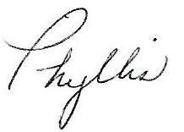

WP 108

[presidentjrc@yahoo.com](mailto:presidentjrc@yahoo.com)

**The JRC Board Members**

President—Phyllis Halpern, WP 108 Music Chair—René Stein, LP 410

Vice-President, Publicity, **Liberty Commons Rep**— Fund Raising Chair, **Keystone Rep**—

Barbara Steiner, BC 419 Sylvia Ziserman, HV 406

Treasurer, Membership—Mimi Travis, MC405 Religious Chair—Steve Capin, TC 507

Recording Secretary—Sandy Heller, PV 118 **Village Reps**—Joan and Marty Freedman, DT 315

Corresponding Secretary—Barbara Josephs, TC 108 At Large—Saul Jacobs, BR 513

Education Chair—Sherry Kohn-Eisman, HV 513 At Large—Vivian Spector, BR 116

**If you meet new residents who are interested in joining us, please refer them to**

**Mimi Travis, Membership Chair.**

What's

Happening in the

JRC

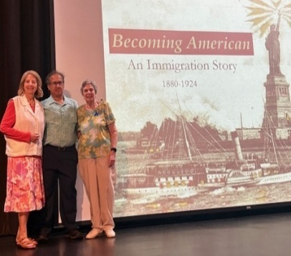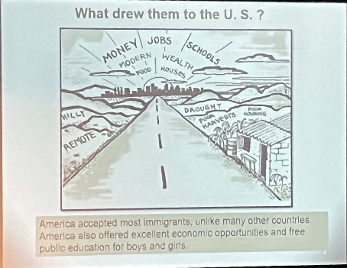

On Wednesday, June 25, we had a lecture/play based on the life of Eva Baen, a young woman from Russia who made her way to the United States alone to start a new life.

We want to thank Fred Fisher, docent, and Carly Paul, Manager of Education, for their knowledge and information. We also want to thank Johanna Dunphy for her historic interpretation of Eva.

The PAC was filled with many interesting residents who shared their stories and the stories of their families as part of the presentation.

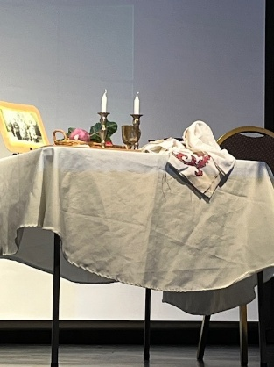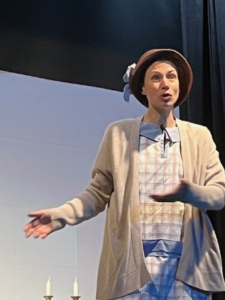

**=================================================================**

**IN MEMORIAM**



If you have any news you wish to share with our members, please send me the information and I will gladly print it in our newsletter. It’s great to share good news as well as sad news.

**=================================================================**

**HADASSAH NEWS**

If you are a member or life member of Hadassah in any chapter, anywhere in the country, you can easily transfer your membership to Newtown Hadassah. You are ALWAYS a life member once you pay the life membership dues.  Just call or write Mimi Travis and she will help you transfer your membership.

Mimi Travis – 215-420-7507 or email me at miriamtravis551@gmail.com

5

6



IS COMING

Elul



6

**ROSH HASHANA IS COMING**

**HIGH HOLIDAY SCHEDULE**

**5786 — 2026**

**IN THE CHAPEL**

**SATURDAY, SEPTEMBER 13 *LEIL SELICHOT***

**7:30 P.M. WITH LEO LEVINE from the**

**Reconstructionist Rabbinical College**

**MONDAY, SEPTEMBER 22 *EREV ROSH HASHANA***

**NO SERVICES**

**TUESDAY, SEPTEMBER 23 *ROSH HASHANA* 5786**

**2 P.M WITH NEIL GOLDSTEIN**

***TASHLICH* AT THE SERENITY GARDENS**

**behind Village Clubhouse**

**4 P.M. WITH NEIL GOLDSTEIN**

**WEDNESDAY, SEPTEMBER 24 *ROSH HASHANA* II**

**NO SERVICES**

**FRIDAY, SEPTEMBER 26 *SHABBAT SHUVA***

**SERVICES, 4 P.M.—  
 JEAN SELTZER delivering Dvar Torah**

**WEDNESDAY, OCTOBER 1 *EREV YOM KIPPUR***

***KOL NIDRE***

**7 P.M. WITH NEIL GOLDSTEIN**

**THURSDAY, OCTOBER 2 *YOM* *KIPPUR***

**2 P.M. WITH NEIL GOLDSTEIN**

**FRIDAY, OCTOBER 3 NO SERVICES**

**MONDAY, OCTOBER 6 *EREV SUKKOT***

**NO SERVICES**

**OCTOBER 7 – OCTOBER 14 *SUKKOT* VISIT OUR SUKKUAH**

**TUESDAY, OCTOBER 14 *SHEMINI ATZERET***

***YIZKOR* SERVICES 2 P.M.**

**WEDNESDAY, OCTOBER 15 *SIMCHAT TORAH***

**NO SERVICES**



7

HELP WANTED

Looking for **A FEW GOOD PEOPLE!!!**

**We need your help if the JRC is to continue being as alive and vibrant as it has been for the past 18+ years!!!**

**We would love your help**

**WORKING IN THE CONTROL ROOM FOR JRC LECTURES AND *SHABBAT* SERVICES**

**We would love your help**

**CONTINUING ALL THE WONDERFUL**

**PROGRAMS IN THE PAC FOR OUR**

**JRC GENERAL MEETINGS AS**

**ENTERTAINMENT CHAIR**

**STEP UP TO THE PLATE AND BE ON THE BEST TEAM AT ANN’S CHOICE!!!!**

**PLEASE** call Phyllis Halpern at 215-675-3637

or

Contact any Board Member

8

****J**EWISH** R**ESIDENTS'** C**OUNCIL**

**To support the Jewish community spiritually, provide opportunities for religious and additional experiences, and encourage social interaction. To nurture respect, understanding and friendship among all residents and faith groups at Ann's Choice.**

**SUSAN SMOLEN**

will be in the PAC on

September 14, 2025

Join us from 3 – 4 p.m.

Susan, the versatile singer, actress and dancer has appeared on stages throughout Philadelphia since she was eight years old. Her repertoire of show-stopping performances covers a variety of holiday and special event themes including Valentine’s Day, St. Patrick’s Day, Christmas, Hanukkah, New Years and many more.

Susan’s vast background working for senior groups, organizations, dinner and community theaters has helped shape her exciting, funny and moving song renditions.

**ADMISSION: $5**

**TO BENEFIT THE RESIDENT BENEVOLENT CARE FUND**

9

J**EWISH** R**ESIDENTS'** C**OUNCIL**

**To support the Jewish community spiritually, provide opportunities for religious and additional experiences, and encourage social interaction. To nurture respect, understanding and friendship among all residents and faith groups at Ann's Choice.**

This year, 5785, the Board of Directors the Jewish Residents’ Council would like to send wishes for a sweet, healthy, happy year to all our members from each of you**. For a donation of $5, you can be included in the list of well-wishers on the card.** Send your check for $5 payable to JRC to Mimi Travis, JRC Treasurer and your name(s) will be listed on our New Year Card.

Please send your donation **no later than August 20, 2025,** to be included.

*B’Shalom*

Phyllis Halpern, President and the Entire Board

J**EWISH** R**ESIDENTS'** C**OUNCIL**

**To support the Jewish community spiritually, provide opportunities for religious and additional experiences, and encourage social interaction. To nurture respect, understanding and friendship among all residents and faith groups at Ann's Choice.**

This year, 5785, the Board of Directors the Jewish Residents’ Council would like to send wishes for a sweet, healthy, happy year to all our members from each of you. **For a donation of $5, you can be included in the list of well-wishers on the card.** Send your check for $5 payable to JRC to Mimi Travis, JRC Treasurer and your name(s) will be listed on our New Year Card.

5Please send your donation **no later than August 20, 2025,** to be included.

*B’Shalom*

Phyllis Halpern, President and the Entire Board