
LIFELONG LEARNING LECTURE SERIES
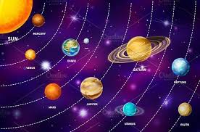

Life on Other Worlds
Extraterrestrial life has been the focus of science fiction, entertainment, and speculation for centuries. But the last 30 years have been a golden age of space exploration and discovery that has energized the topic and raised the serious possibility that at least some form of life beyond Earth may actually be discovered in the next few decades. Robot probes to Mars and the outer reaches of our Solar System have uncovered possible habitats of primitive life, and space-based observatories such as the Hubble and James Webb Space Telescopes have discovered thousands of planets orbiting distant stars. Observations of some of these highlight the possibility that life might actually be common in our galaxy. In this talk we’ll discuss the history of the search and what some of those discoveries look like, including examples right here on Earth of “alien” life forms that can survive under the most extreme conditions imaginable.

Instructor: Dr. Richard Isaacman
B.A., Cornell University
Ph. D., Leiden University (The Netherlands)
Dr. Richard Isaacman is a retired NASA astronomer and program manager. His research has included the search for extraterrestrial life, the properties of very old stars, and the Big Bang origin of the universe. He was the head of the Science Software Team for NASA’s first cosmology satellite and worked with Carl Sagan at Cornell University on the search for extraterrestrial intelligence. In that role he was a co-author of the first transmitted message that was a deliberate attempt to contact hypothetical extrasolar civilizations.
Monday, November 17, 2025
1:3O- PM – 3:00 PM
LIBERTY PERFORMING ARTS CENTER (PAC)
Cost: $5 payable at the door
Doors close promptly at 1:30 PM

