 JEWISH RESIDENTS' COUNCIL

To support the Jewish community spiritually, provide opportunities for religious and additional experiences, and encourage social interaction. To nurture respect, understanding and friendship among all residents and faith groups at Ann's Choice.

December 2025
Kislev/Tevet 5786

CHANUKAH—DECEMBER 14, 2025 THROUGH DECEMBER 22, 2025

Monday, December 1: JOE SHRAGER MEMORIAL TORAH STUDY 2 p.m., Liberty Commons
Art Room with Rabbi Miller

Friday, December 4: Kabbalat Shabbat Services at 4 p. m. in the Chapel or on Channel 976 or 980
Torah Portion: Vaayishlach Rabbi Robert Lieb of Old York Road Temple Beth Am will be davening with us.

Monday, December 8: NO TORAH STUDY

Friday, December 12: Kabbalat Shabbat Service at 3:30 p.m. in the Chapel or on Channel 976 or 980 Torah Portion: Vayeshev Rabbi Elliot Perlstein, Rabbi Emeritus of Ohev Shalom will be davening with us.

CHANUKAH—DECEMBER 14, 2025 THROUGH DECEMBER 22, 2025

Sunday, December 14: OUTDOOR CHANUKIAH LIGHTING,
BY THE GAZEBO, 4:15 P.M.

Monday, December 15: NO TORAH STUDY
CHANUKAH: 2 CANDLES

Thursday, December 18: Chanukah Meet and Greet Candle Lighting Party, Liberty Commons Catering Room 7:00 p.m., PRIOR RSVP required

Friday, December 19: Kabbalat Shabbat Services at 4 p.m. in the Chapel or on Channel 976 or 980
Torah Portion: Miketz Soni Feld will be delivering the D’var Torah
ROSH CHODESH TEVET CHANUKAH: 7 CANDLES

Sunday, December 21: ROSH CHODESH TEVET CHANUKAH: 8 CANDLES

Monday, December 22: NO TORAH STUDY

Wednesday, December 24: JRC Lecture Series, in the PAC, at 2 p.m., Michael Eisman will present
THE JEWS OF ANCIENT ROME

Friday, December 26: Kabbalat Shabbat Services at 4 p.m. in the Chapel or on Channel 976 or 980
Torah Portion: Vayigash NEW MEMBER SHABBAT

Monday, December 29: NO TORAH STUDY

Wednesday, December 31: NEW YEAR'S EVE 2026

THANK YOU TO THE FOLLOWING FOR THEIR VERY GENEROUS DONATIONS TO THE JEWISH RESIDENTS' COUNCIL:

BY IN MEMORY OF
Leanne Shulman Sellig Shulman
Alice Forman Saundra Neiderman
Roberta Dunaief Charles Silverberg
Phyllis Halpern Sandi Spivack
Rhoda Sterling and Lewis Zatz Bobby Markowitz, brother of Rhoda Sterling
Sheila Newman Saundra Neiderman
Rochelle and Saul Jacobs Saundra Neiderman
Janice Pincus David Factor, beloved father
Harvey Factor, beloved brother
Sheila Johnson Lena Palais, beloved mother
Tamar Adini Elizabeth Löw,
Jacqueline Matusow Meyer Matusow, beloved father
Marlene Block my beloved husband, forever in my heart, Marvin Block
Marilyn Bartikowsky Leonard (Bart) Bartikowsky
Mimi Travis Leonard Borthwick
Norma Segal Sidney Segal, beloved husband
Phyllis Halpern Saundra Neiderman
Leonard Borthwick, beloved husband of Trudy Borthwick
Ellen and Saul Miller Esther Miller, beloved mother
Milton Miller, beloved father

BY IN HONOR OF
Estelle and Bob Master Phyllis Halpern and the JRC Board for all they do for
the Jewish Community at Ann's Choice
Kate Korn
Judith Lappen Phyllis Halpern and all who performed for the High Holy Days Services
Irma Sklut being a member of the JRC and everything they do for us
Harriet Baum Kate Korn
Alice Forman Marty Fineberg
Selma and Joseph Blatt Marvin Kreithen's BIG BIRTHDAY
Carol Cohen being a member of the JRC and everything the JRC does for our Jewish population
Janet and Michael Levinton the Holiday Services and having JRC here at Ann's Choice
Roslyn Katz Services on October 13
S. Gail Sussman the JRC, all members and everything that JRC does
Delcy Weinberg Ines Cohen
Shoshana Gruen Nurit Binenbaum's birthday in November
Mimi Travis' birthday in November
Marlene Block Marvin I Block
Sybil Cooper Marvin Kreithen's 90th birthday
Gloria Ceaser Norma Levin's 100 birthday
Delcy Weinberg's 100 birthday
Edna Pincus' birthday
Sandra and Michael Bernstein Marvin Kreithen's 90th birthday
Phyllis Halpern Marvin Kreithen's 90th birthday
Delcy Weinberg's 100 birthday
Ira Friedman all the JRC members and happy to have this Faith Group here at Ann's
Choice and all people that I know

*HAPPY BIRTHDAY*

Laurie Capin, Joyce B. Cohen, Claire Goldstein, Eileen Baskin, Joan Marks, Ruth Worms, Joan Chertok, Sue Ross, Gloria Ceaser, Michael Sultanik, Vivian Spector, Barbara Stone, Lester Altman, Florence Ginsburg, Steve Binenbaum, Jean Seltzer, Steve Capin, Arthur Geller, Marilyn Lashen, Phyllis Turek, Phyllis Halpern

I want to wish everyone who is celebrating a birthday in December a yom hu'ledet sameach. If your name is not on the list, please let me know your birth date and you will be included next December.

**MISHEBERACH **
WE PRAY FOR HEALING

For all our family, friends and residents who are ill, in the hospital or in RG or other nursing homes.

***YAHRZEITS***

During the period of 11 Kislev to 11 Tevet, we remember our friends and family who are no longer with us:

Alexander Richman, Jeffrey Berman, Isador Goldstein, Myer Ostroff, Ira Abromovitz, Morris Broder, Benjamin Glazman, Jacob Kreithen, Eadie Glassman, Arthur Gendler, Rochelle Schwartz, Morris Cohen, Frances Altshul, David Carmen, Ellen Auslander, Sandra Borochaner, Elmer Hanock, Rose Kaplan, Bernard Miller, B. Meyer Simon, Elizabeth Worms, Jeanette Shapiro, Sylvia Mayover, Ester Olim, Harvey Steinberg, Evie Brezo, Edward Gelb, Cheryl Beth Silverman, Joseph Fisher, Harold Prutkin, Andy Frank,
Michael Friedman, Melvin (Mickey) Lipman, Herbert Klein, Abraham Malenbaum, Esther Glickman, Jerrold Schoenblum, David Chary, Albert Sutow, Kathryn Kesselman, Morton Katz, Charlotte Yudell, Lawrence Broder, Max Caroll, Max Litz, Mara Sculler, Hilda Boyer, Elfriede Franke, Louis Kaplan, Ruth Master, Geraldine Silver, Louis Hayden, Rose Marcus, Benjamin Cohen, Ted Cooper, Irene Pressel, Oscar Salem, Sarah Salosky, Gussie Friedman, Bruce Kliman, Rose Cohen, Alan Pilzer, Rabbi Daniel Kaplan

If there are errors or additions, please put a note in Phyllis Halpern’s cubby—WP 108.

May all their memories be for a loving blessing, and their lives be an inspiration to us all.


PRESIDENT'S MESSAGE

HAPPY BIRTHDAY to all of us who were born in December. What a great month for a birthday! Please join us on Friday, December 26, at 4 p.m. in the Chapel for our NEW MEMBER SHABBAT when we will have a special blessing for new residents who have joined us since this past June. Plan to attend services to welcome new residents to Ann’s Choice. I also want to wish everyone a HAPPY CHANUKAH. We will be having a celebration with our outdoor Chanukiah this year on Sunday, December 14, at 4:15 p.m., which will be lit every night during Chanukah. I hope everyone enjoys our outdoor Chanukiah! Join us Thursday, December 18, in the Liberty Commons Catering Room at 7 p.m. for our CHANUKAH MEET AND GREET CANDLE LIGHTING PARTY. Send in your RSVP early so we can plan refreshments for the party. I can hardly believe that in just a few weeks it will be 2026! Remember—DUES for the coming year, $10 per person!
-
Thank you to Doris Grossman, who diligently and lovingly provides our refreshments after all of our General Meetings.

The Board wishes a Bright and Healthy Chanukah to All the Shabbat Services Leaders: Steve Capin, Judy Maslin, René Stein, Barbara Steiner, Mimi Travis; to all those in the sound room: Bobbie Dunaief, Ed Lashen, Ellen Newman, Lynne Plunkett, Mickey Sultanik, Gary Weisser. And All the JRC Residents in attendance and watching services on TV, and everyone else. A VERY HAPPY HEALTHY NEW YEAR 2026 TO ALL THE JRC MEMBERS AND ANN’S CHOICE RESIDENTS AND STAFF!!
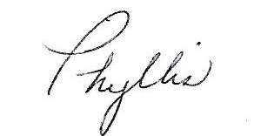

jWP 108
presidentjrc@yahoo.com
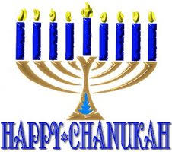

The JRC Board Members
President—Phyllis Halpern, WP 108 Music Chair—René Stein, LP 410
Vice-President, Publicity, Liberty Commons Rep— Fund Raising Chair, Keystone Rep—
Barbara Steiner, BC 419 Sylvia Ziserman, HV 406
Treasurer, Membership—Mimi Travis, MC405 Religious Chair—Steve Capin, TC 507
Recording Secretary—Sandy Heller, PV 118 Village Rep—Joan and Marty Freedman, DT 315
Corresponding Secretary—Barbara Josephs, TC 108 At Large—Saul Jacobs, BR 513
Communications Chair—Arline Olim, BR 516 At Large—Vivian Spector, BR 116
Education Chair—Sherry Kohn-Eisman, HV 513

If you meet new residents who are interested in joining us, please refer them to
Mimi Travis, Treasurer.


==================================================================

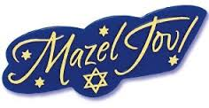
A Mazel Tov to Vivian Spector on the birth of her two newest GREAT GRANDCHILDREN, cousins Ayala and Noah.

A Mazel Tov to Delcy Weinberg on the birth of her first GREAT GRANDDAUGHTER, Ines Cohen.

==================================================================

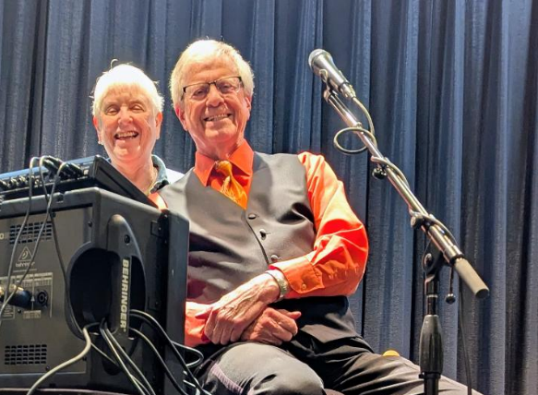
Everyone really enjoyed Bruce Copp at our General Meeting. Our last meeting for 2025 will be November 13. Hope we have a great turnout.

Bruce Copp with Mimi Travis at the October General Meeting

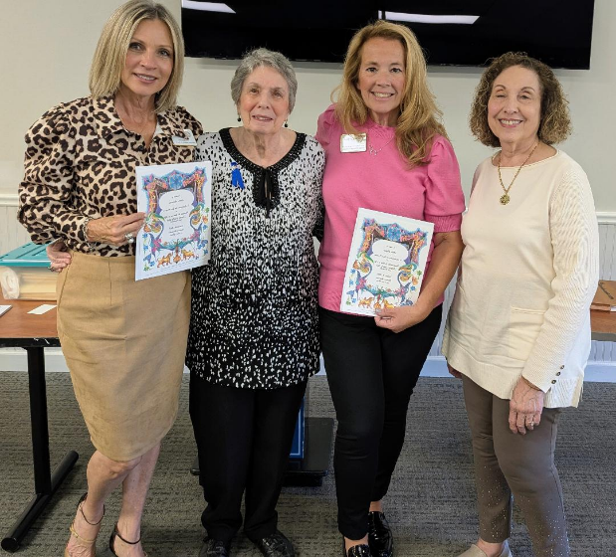
At our October Hadassah meeting we had two wonderful women who specialize in Elder Law, speak to us about all the important things we need as we get older to make sure all of our wishes are respected. We had over 25 people attend this important meeting.

Pictured l to r: Linda Amorosi; Phyllis Halpern; Anne Crozier; Eileen Weinstein, president of Newtown Hadassah

JRC LECTURE SERIES
Presents

Michael Eisman
on December 24, 2025
in the PAC, 2 p.m.

THE JEWS OF ANCIENT ROME

There were Jews in Ancient Rome as early as 161 B.C.E., but by the time of the Roman Empire (31 B.C.E. - 565 C.E.) Jews made up about 10% of the empire and a higher percentage in the city of Rome itself. The community in the city had eleven congregations although not all were in operation at the same time. Highly organized synagogues not only provided for the religious and educational needs, but also provided rooms for traveling Jews.

Most of our knowledge comes from the over six hundred inscriptions in stone from the three major Jewish catacombs that were excavated by the Vatican. On one level they show us the community organization, its rituals and ideas. Many show the human emotions of the inscribers.

They show not only synagogue organization by a community wide organization as well. This organization sent representative to an empire organization and its leader the Ethnarch who as able to communicate directly with the Roman government. Altogether we get a surprisingly modern look to ancient Jewish Rome.
Michael M. Eisman is a retired Temple University professor of Ancient History and Classical Archaeology having received his degrees from the University of Michigan (B.A. and M.A.) and the University of Pennsylvania (Ph.D.). Working in the Ancient World, Dr. Eisman has spent a lot of time working in Rome and became interested in the Jewish community during antiquity. He is glad to present this portrait of the community.
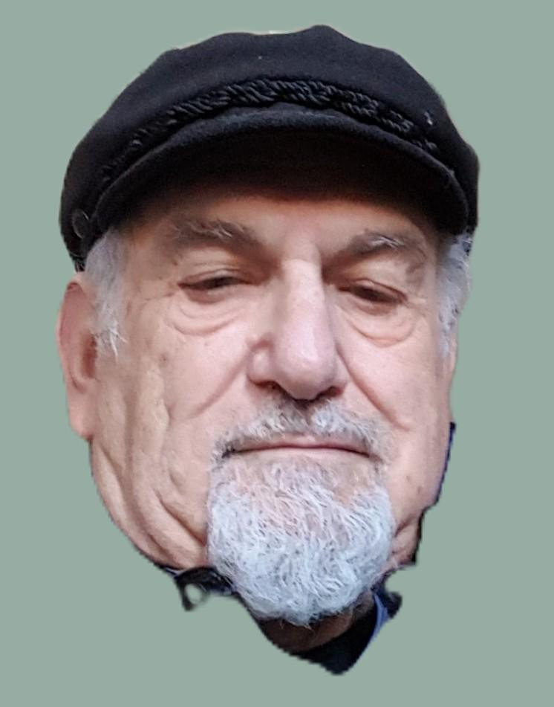

Your $2 donation will benefit the
Resident Benevolent Care Fund

ALL ARE WELCOME!!

HADASSAH MEMBERS

If you are a life member of Hadassah in any chapter, anywhere in the country, you can easily transfer your membership to Newtown Hadassah. Just call or write Mimi Travis and she will help you transfer your membership. You are ALWAYS a life member once you pay the life membership dues. You can always join Hadassah, if you are not yet a member. Call Mimi. Please make you Annual Donation now; send it, addressed to Mimi Travis, Hadassah, and take to your clubhouse front desk. It will be placed in our secure lockbox.
OUTDOOR CANDLE LIGHTING
BY THE GAZEBO
WEATHER PERMITTING
Sunday, December 14, at 4:14 p.m.
Join us for candle lighting, prayers and songs.



Join us at the
CHANUKAH MEET AND GREET
CANDLE LIGHTING PARTY
DECEMBER 18, 2025
LIBERTY COMMONS CATERING ROOM
7:00 P.M.
Enjoy Chanukah Sufganiyot and Coffee/Tea

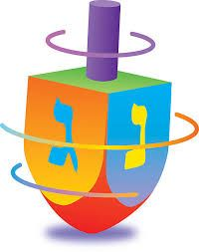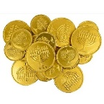
BILL FRYE
ENTERTAINING

LET US KNOW YOU’RE COMING
BY December 8,2025 CHANUKAH MEET AND GREET
NAME _________________________________
CUBBY ___________________ EMAIL __________________________
Return to front desk: ATTENTION: JRC—Mimi

