GENERAL BOARD (CON’T)

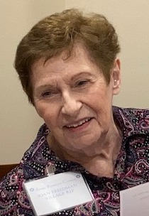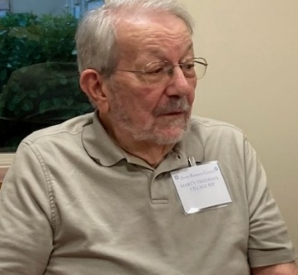
JOAN AND MARTY FREEDMAN
VILLAGE REPRESENTATIVES

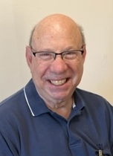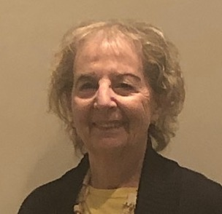
SAUL JACOBS VIVIAN SPECTOR
AT LARGE AT LARGE

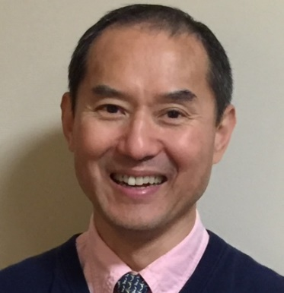
KANG NA PASTORAL
MANAGER

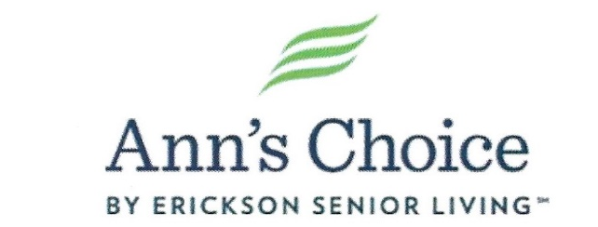

JEWISH RESIDENTS' COUNCIL

To support the Jewish community spiritually, provide opportunities for religious and additional experiences, and encourage social interaction. To nurture respect, understanding and friendship among all residents and faith groups at Ann's Choice.

THE JRC BOARD MEMBERS

EXECUTIVE BOARD

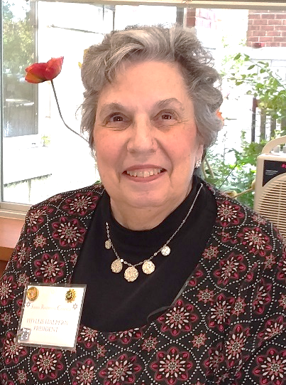
PHYLLIS HALPERN
PRESIDENT

EXECUTIVE BOARD (CON’T)

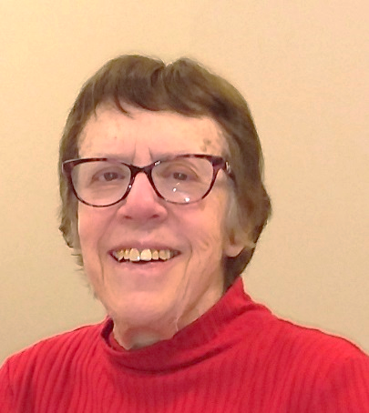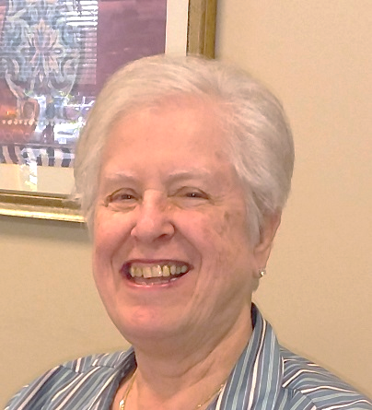
BARBARA STEINER MIMI TRAVIS
VICE-PRESIDENT TREASURER
LIBERTY REPRESENTATIVE MEMBERSHIP
PUBLICITY
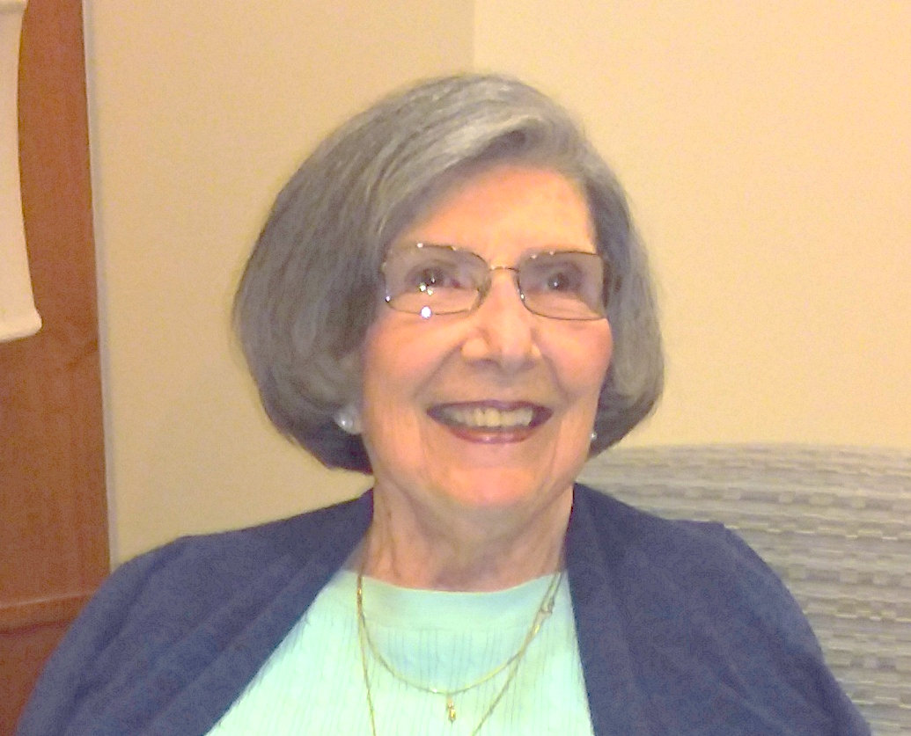
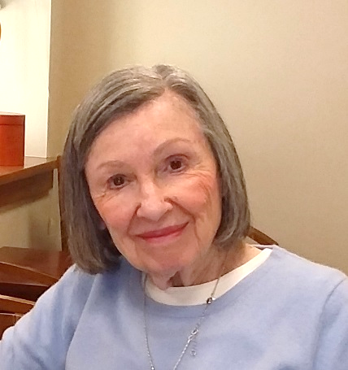
SANDY HELLER BARBARA JOSEPHS
RECORDING CORRESPONDING
SECRETARY SECRETARY

GENERAL BOARD

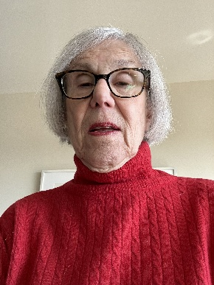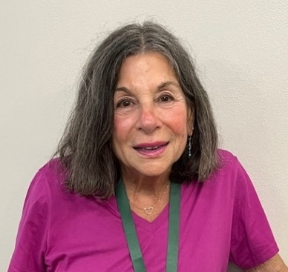
ARLINE OLIM
COMMUNICATIONS CHAIR

SHERRY KOHN EISMAN
EDUCATION CHAIR

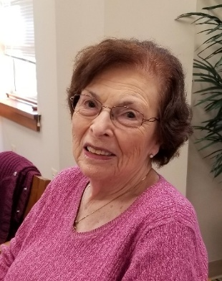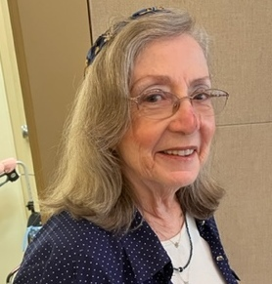
SYLVIA ZISERMAN
FUNDRAISING CHAIR
KEYSTONE REPRESENTATIVE
RENÉ STEIN
MUSIC CHAIR

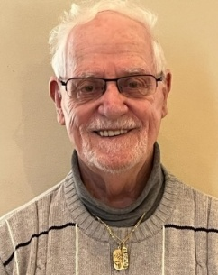
STEVE CAPIN
RELIGIOUS CHAIR
JOAN AND MARTY FREEDMAN
VILLAGE REPRESENTATIVES

