
LIFELONG LEARNING LECTURE SERIES
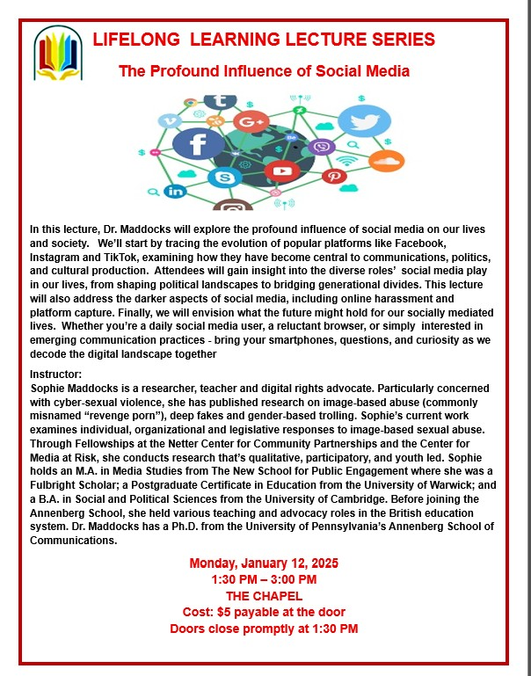The Profound Influence of Social Media

In this lecture, Dr. Maddocks will explore the profound influence of social media on our lives and society. We’ll start by tracing the evolution of popular platforms like Facebook, Instagram and TikTok, examining how they have become central to communications, politics, and cultural production. Attendees will gain insight into the diverse roles’ social media play in our lives, from shaping political landscapes to bridging generational divides. This lecture will also address the darker aspects of social media, including online harassment and platform capture. Finally, we will envision what the future might hold for our socially mediated lives. Whether you’re a daily social media user, a reluctant browser, or simply interested in emerging communication practices - bring your smartphones, questions, and curiosity as we decode the digital landscape together
Instructor:
Sophie Maddocks is a researcher, teacher and digital rights advocate. Particularly concerned with cyber-sexual violence, she has published research on image-based abuse (commonly misnamed “revenge porn”), deep fakes and gender-based trolling. Sophie’s current work examines individual, organizational and legislative responses to image-based sexual abuse. Through Fellowships at the Netter Center for Community Partnerships and the Center for Media at Risk, she conducts research that’s qualitative, participatory, and youth led. Sophie holds an M.A. in Media Studies from The New School for Public Engagement where she was a Fulbright Scholar; a Postgraduate Certificate in Education from the University of Warwick; and a B.A. in Social and Political Sciences from the University of Cambridge. Before joining the Annenberg School, she held various teaching and advocacy roles in the British education system. Dr. Maddocks has a Ph.D. from the University of Pennsylvania’s Annenberg School of Communications.
Monday, January 12, 2025
1:30 PM – 3:00 PM
THE CHAPEL
Cost: $5 payable at the door
Doors close promptly at 130 PM

