 JEWISH RESIDENTS' COUNCIL

To support the Jewish community spiritually, provide opportunities for religious and additional experiences, and encourage social interaction. To nurture respect, understanding and friendship among all residents and faith groups at Ann's Choice.

February 2026
Shevat/Adar 5785

Friday, February 6: Shabbat Services—In the Chapel 4 p. m. Torah Portion: Yitro
Rabbi Benjamin David from Keneseth Israel will be leading our davening.

Monday, February 9: No Torah Study

Friday, February 13: Shabbat Service—In the Chapel 4 p. m. Torah Portion: Mishpatim, Barbara Steiner will be delivering the D’var Torah.

Monday, February 16: No Torah Study,
PRESIDENTS' DAY

Tuesday, February 17: ROSH CHODES ADAR
Wednesday, February 18: ROSH CHODES ADAR

Thursday, February 19: Hadassah meeting, 1 p.m. Village Music Room, Marty Sherman presents: EVERYTHING YOU ALWAYS WANTED TO KNOW ABOUT MEDICARE

Friday, February 20: Shabbat Service— In the Chapel 4 p. m. Torah Portion: Terumah
Tamar Adini will be delivering the D’var Torah.

Monday, February 23: No Torah Study
Wednesday, February 25: JRC Lecture Series, in the PAC 2 p.m. Karl Middleman
Please Pass the Grits and Gefilte Fish, Part II

Friday, February 27: Shabbat Service— In the Chapel 4 p. m. Torah Portion: Tetzaveh
Michael Sultanik will be delivering the D’var Torah
SHABBAT ZACHOR

EVENTS IN MARCH
Tuesday, March 3: Come Hear the Megillah Reading, 12:30 p.m., in the Chapel

Monday, March 16: Torah Study, 2 p.m., Liberty Commons Art room
THANK YOU TO THE FOLLOWING FOR THEIR VERY GENEROUS DONATIONS TO THE JEWISH RESIDENTS' COUNCIL:

BY IN MEMORY OF
Robert Master Ruth Master, beloved mother
Steve Rodos Dee Rodos
Judith and Ramon Baker Jules and Ethel Matusow, beloved parents
Philip and Anna Baker, beloved parents
Judy Tashman Michael Friedman, beloved father
Alice Forman Rona Altman
Gloria and Irving Safra Albert Sutow
Etta Krauss Max Litz, beloved father
Sandra Berman Benjamin Cohen, beloved father
Annette and Allen Herring Rona Altman
Marilyn and Donald Webster Eadie Glassman
Morris Broder, beloved father
Lawrence "Larry" Broder, beloved brother
Rochelle and Saul Jacobs Ruth Butchin
Rona Altman
Herbert Vernick
Thelma Krefetz Judy Rosenberg
Jean and Richard Seltzer our daughter, Evelyn Seltzer Khan
Joan Winokur Benjamin Gelman, beloved father
Emanuel Winokur, beloved husband
Rita Olen Gerald Olen
Barbara Steiner Judy Rosenberg
Marilyn Kraft Marcy Kraft, beloved daughter
Sandra Berman Judy Rosenberg
Phyllis Halpern Judy Rosenberg
Marlene Rubenstein
Michael Kaplan
Joyce Cohen
Florence Gendler mother of Scott Elian
Rochelle Pilzer Alan Pilzer, beloved husband
Ann Kalmanor Michael Kaplan
Mimi Travis Joyce Cohen, rest in eternal peace
Marlene Rubenstein, rest in eternal peace
Michael Kaplan, rest in eternal peace
Amiram Amitai Diane Amitai
Bernice and Robert Chast mother's yahrzeit and father's yahrzeit,
Linda Pressman Michael Kaplan

BY IN HONOR OF
Norma Segal the JRC, all members and everything that JRC does
Vivienne Friedman Delcy Weinberg for her 100th birthday
Jean and Richard Seltzer the JRC and all it does for us
Rita Olen Delcy Weinberg's 100th birthday
JRC Board and all members Susan and Neil Mittelman on the Bar Mitzvah of their
grandson, Evan Mittelman
Etta Krauss Delcy Weinberg's 100th birthday
Jean and Richard Seltzer the JRC for a Happy and Healthy New Year
Sheila Johnson Delcy Weinberg's 100th birthday
Maxine Knesbach Delcy Weinberg's 100th birthday
Judith Maslin all who work so hard for the JRC. Much appreciated.
Barbara Steiner a speedy recovery to Helene Malenbaum
Phyllis Halpern good health for Helene Malenbaum
Gail and Allen Silverberg Phyllis Halpern for her kindness to me. She is an amazing person and has
always been kind to us, as was her spouse, Mel, of blessed memory.
**HAPPY BIRTHDAY**

Marlene Simons, Thelma Krefetz, Rhoda Simon, Saul Jacobs, Sandy Heller, Barbara Fuchs and Joan Lipman.

If your name is not on the list, please let me know your birth date and you will be included next February.

*MISHEBERACH *
WE PRAY FOR HEALING

For all our residents who are ill, in the hospital or in RG or other nursing homes.

**YAHRZEITS**

During the month of 14 Shevat to 11 Adar 11we remember our friends and family who are no longer with us:

Herman L. Lipman, Samuel Löw, Irv Segal, Helen Shine, Richard Yusem, Charles Serotta, Lois Gitter, Lynn Goodman, Ruth Silverstein, Ronald Horloff, Pearl Carman, Harry Feinman, Lana Borochaner, Jason Helfond, Harold Pressman, Dennis Lever, Rose Feld, Ann Schwartz, Bruce D. Shuter, Norton Borochaner, William Dunaief, Beryl Gottesman, Theodore Jacobs, Esther Segal, Robert Boyer, Brenda Carmen, Sidney Kauffman, Franklin Oberstein, Edward Shilling, Shari Brodsky, Norton Ginsburg, Netti Salamon, Meyer Heiman, Dr. Benson J. Horowitz, Freda Sollod, Adolph Spector, Dorothy Sultanik, Barry Mittelman, George Stein, Frances Zicherman, Beryl Hamerla, Mollie Wisotsky, Newton Garber, Shirley Silverstein, William Shnycer, Belmont Haydel, Irvin Cohen, Gerald M. Fisher, Alvin Pearlman, Benjamin Gersh,

If there are errors or additions, please put a note in Phyllis Halpern’s cubby--WP 108.

May all their memories be for a loving blessing, and their lives be an inspiration to us all.


PRESIDENT'S MESSAGE

Our Chanukah party, held on Thursday, December 18, 2025, was a huge success. Thank you to everyone who attended. A very special thank you goes to the JRC Board for all your help and support during the holiday and especially at the party. Thank you to Bill Frye for a wonderful evening of entertainment.

If you have not sent me your Yahrzeit information, you can still do it. Just make sure you include the day, month and year of death. I can get the Hebrew date, if you don’t know it. Your loved one’s Yahrzeit will be read at services on the Shabbat following the appropriate Hebrew date.
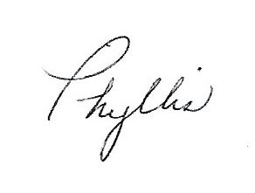
WP 108
presidentjrc@yahoo.com

The JRC Board Members
President—Phyllis Halpern, WP 108 Music Chair—René Stein, LP 410
Vice-President, Publicity, Liberty Commons Rep— Fund Raising Chair, Keystone Rep—
Barbara Steiner, BC 419 Sylvia Ziserman, HV 406
Treasurer, Membership—Mimi Travis, MC405 Religious Chair—Steve Capin, TC 507
Recording Secretary—Sandy Heller, PV 118 Village Rep—Joan and Marty Freedman, DT 315
Corresponding Secretary—Barbara Josephs, TC 108 At Large—Saul Jacobs, BR 513
Communications Chair—Arline Olim, BR 516 At Large—Vivian Spector, BR 116
Education Chair—Sherry Kohn-Eisman, HV 513

If you meet new residents who are interested in joining us, please refer them to
Mimi Travis, Treasurer.





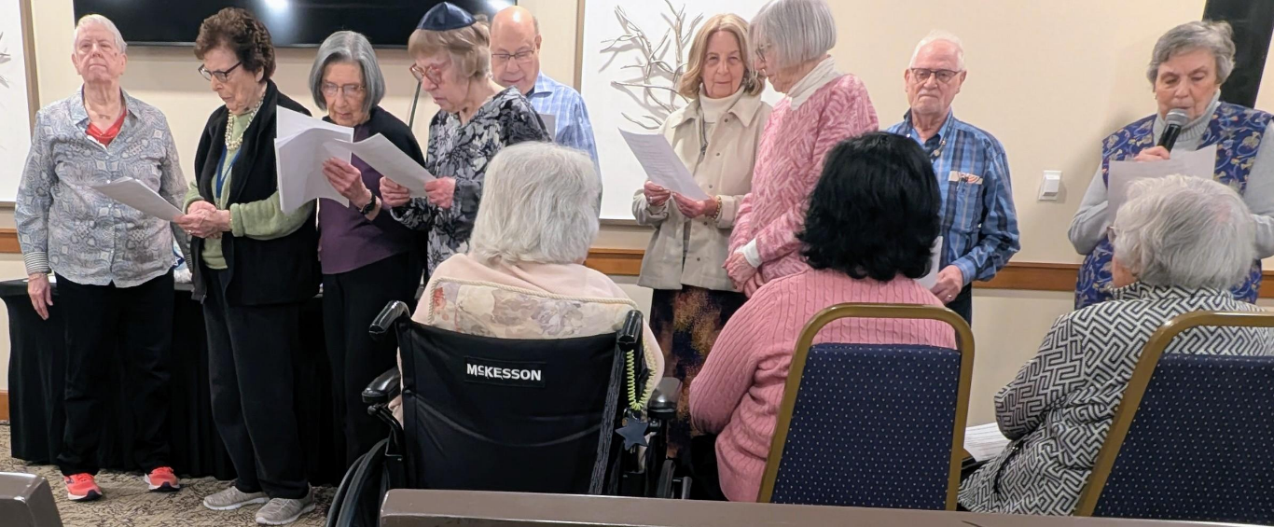
The Board Members at our Chanukah celebration reading a beautiful tribute to the holiday before Bill Frye entertained us.

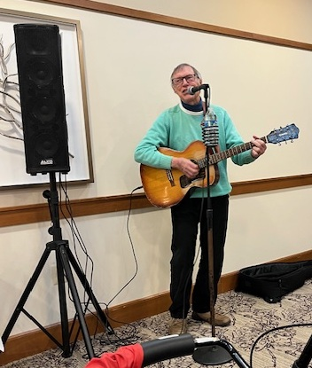
On Thursday, December 18, we had the BEST Chanukah party ever. With over 100 people in the Catering Room, we lit the Chanukah candles, said the prayers and sang songs. Then Bill Frye entertained us with his amazing voice and personality. Thank you to everyone who made this night happen and to all who attended.
5

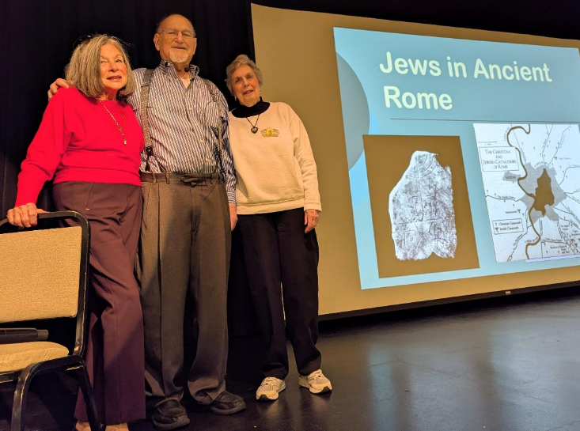
In December, Michael Eisman gave a wonderful lecture on THE JEWS OF ANCIENT ROME. The information was very interesting and the slides he presented made it even more interesting.

l to r: Sherry Kohn-Eisman, Education Chair; Michael Eisman, speaker; Phyllis Halpern, President

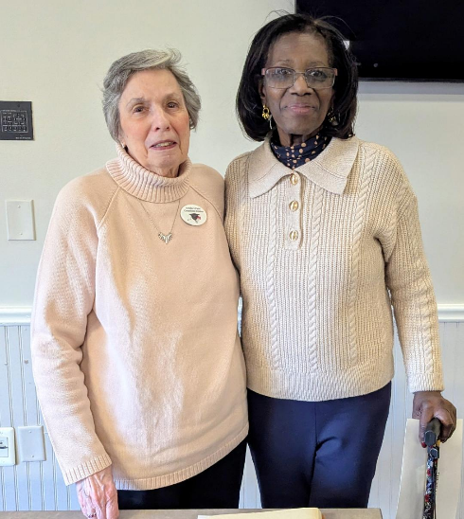
At our January Hadassah meeting, speaker Sheila Berg told us about her journey to Judaism, the military as a Jet Engine Mechanic for the C-5, 141 airplanes and her work at Dover Air Force Base as a First Sergeant for Mission Support. She is also a social worker with Children, Adults and the Elderly.

l to r: Phyllis Halpern, President; Sheila Berg, speaker

==================================================================
IN MEMORIAM

If you have any news you wish to share with our members, please send me the information and I will gladly print it in our newsletter. It’s great to share good news as well as sad news.

==================================================================

6

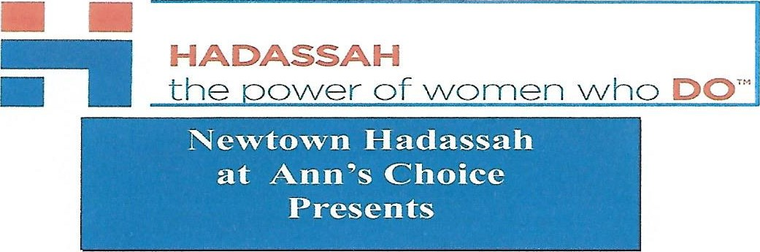
THE NEXT HADASSAH MEETING IS
THURSDAY, February 19, 2026
IN THE VILLAGE MUSIC ROOM AT 1 P. M.
WE ARE JOINED BY

Marty Sherman

as he presents
EVERYTHING YOU ALWAYS WANTED TO KNOW
ABOUT MEDICARE

ALL ARE WELCOME!!
8

7

JRC LECTURE SERIES
Presents

Karl Middleman
Part II on February 25, 2026
in the PAC, 2 p.m.
Please Pass the Grits and Gefilte Fish

Jewish Contributions to the Harlem Renaissance

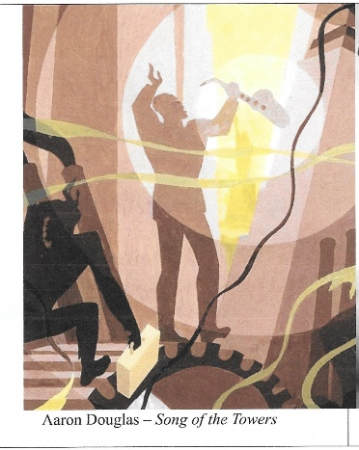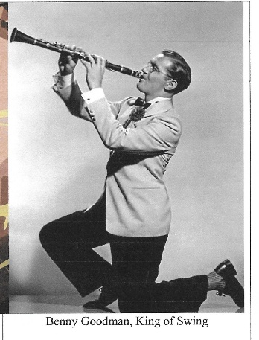
As they chased the good life in the 1920's and '30's, Americans searched for new ways to spend their leisure time. Harlem became an arts mecca for the full flowering of African-American culture. Jazz was its key emblem. Jazz was found everywhere: in speakeasies, dancehalls, homes, even in railroad cars. George Gershwin and Milton Berle (Mr. Television) frequented Harlem's cathedral of entertainment, the Apollo Theater where Ella Fitzgerald made her debut in 1934. In the Savoy Ballroom, owned by the Jewish businessman, Moe Gale, the battling bands of Chick Webb and Count Basie squared off against each other while 2,000 couples danced the Lindy Hop. Historians usually focus on antagonisms between Blacks and Jews during the period of the Harlem Renaissance. Yet significant strides toward racial equity were made by Sophie Tucker, Benny Goodman and other great Jewish entertainers. Aided by a wide range of rare and pleasurable music videos, Karl Middleman tells the story of the glorious music of the Harlem Renaissance with a focus on contributions by Jews to the cause of improving race relations.

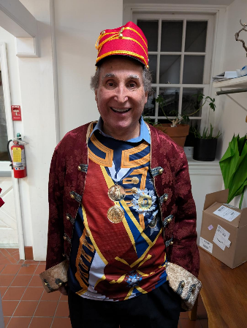 ALL ARE WELCOME!!
Karl Middleman is equally at home with Rodgers and Hammerstein as he is with Handel and Haydn. He has been hailed for the easy ways his presentations mix scholarship with showmanship. Peppered with possibilities for participation, Maestro Karl's presentations demonstrate that teaching classical music need not be rarified and exclusionary, but fun and fulfilling.

Your $2 donation will benefit the
Resident Benevolent Care Fund

JEWISH RESIDENTS' COUNCIL
8

COME HEAR THE MEGILLA

TUESDAY, MARCH 3, 2026
12:30 P. M.
IN THE CHAPEL



9
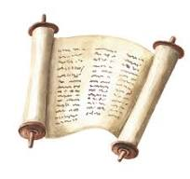

TORAH STUDY
IS BACK!

JOIN US MONDAY, MARCH 16, 2026
LIBERTY COMMONS ART ROOM
2 P.M. – 3:30 P.M.

RABBI DANIEL MILLER RETURNING
10

